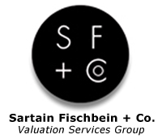
Jeremy C. Jennings, CPA/ABV
Senior Manager
Management Advisory Services
Sartain Fischbein + Co.
3010 S. Harvard Avenue, Suite 400
Tulsa, OK 74114
Phone: 918.749.6601
www.sfandco.com
Jeremy C. Jennings, CPA/ABV received his B.S. in Accounting from Oklahoma State University in 2001. He is a member of the American Institute of Certified Public Accountants and has earned the Accredited in Business Valuation (ABV) credential. Jeremy has held various positions in public and private accounting over the past twelve years and is currently a Senior Manager in the Management Advisory Services Department of Sartain Fischbein + Co. He has broad auditing, tax and consulting experience in, among others, the wholesale/retail, service, manufacturing, and auto dealer industries.
Jeremy performs numerous business valuations annually for various purposes including estate and gift tax. He has also provided services, including the issuance of expert reports, in connection with a variety of lawsuits involving damages and various other business issues.

