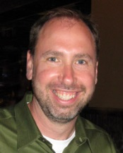

Jeffrey Alderman
Clinical Associate Professor
OU School of Community Medicine
Medical Director, Sooner Health Access Network

Dr. Alderman is Clinical Associate Professor of Medicine at the University of Oklahoma School of Community Medicine, where he has practiced and taught Palliative Medicine since 2002. He founded two Palliative Care inpatient consult services in the Tulsa Community, and continues to consult in hospice medicine. In his new role as Medical Director of the statewide Sooner Health Access Network, Dr. Alderman is studying ways to leverage Care Coordination to improve the health of low-income Oklahomans. He earned his M.D. at George Washington University, and completed his residency in Internal Medicine at Mount Auburn Hospital/Harvard Medical School; he received additional training in Palliative Medicine at Stanford University. Dr. Alderman recently earned a Master’s Degree in Health Care Delivery Science this year at Dartmouth College.

