

Executive Profile

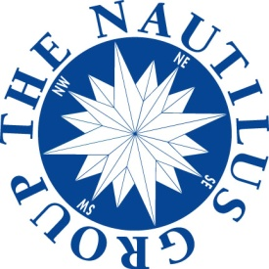

Jim Barry serves as the head of the Nautilus Plus unit at The Nautilus Group, providing personalized consultative services to an elite group of 25 Plus Member Agents, bringing their clients solutions for estate, business, insurance and charitable planning.

Jim and his staff are also available as a resource to facilitate the brainstorming process between the Nautilus Member Agent, the client, and the client’s circle of advisors.

Jim has been in the life insurance industry since 1982. Prior to joining Nautilus in 1998, he worked at three national life insurance companies.

He has written numerous articles on deferred compensation, split-dollar, estate planning techniques, and matching life insurance solutions to client goals and objectives. He also has spoken at AALU meetings, life insurance industry meetings, and numerous estate planning councils.

Jim received his law degree from the University of Georgia and his LL.M. in taxation from the College of William and Mary. He also attended the University of Miami’s LLM program in Estate Planning.

Jim is a member of AALU and the Business Insurance and Estate Planning Committee. He also is a member of the American Bar Association and the State Bar of Georgia.

Jim lives in Dallas with his wife, Patrice, and his son, James IV.

**James S. Barry, JD, LL.M., CLU®, ChFC®**

*Corporate Vice President*

*Director, Nautilus Plus*

*The Nautilus Group®*